**9.3 - Try to map the relational schema of Figure 6.6 into an ER schema. This is part of a process known as reverse engineering, where a conceptual schema is created for an existing implemented database. State any assumptions you make.**

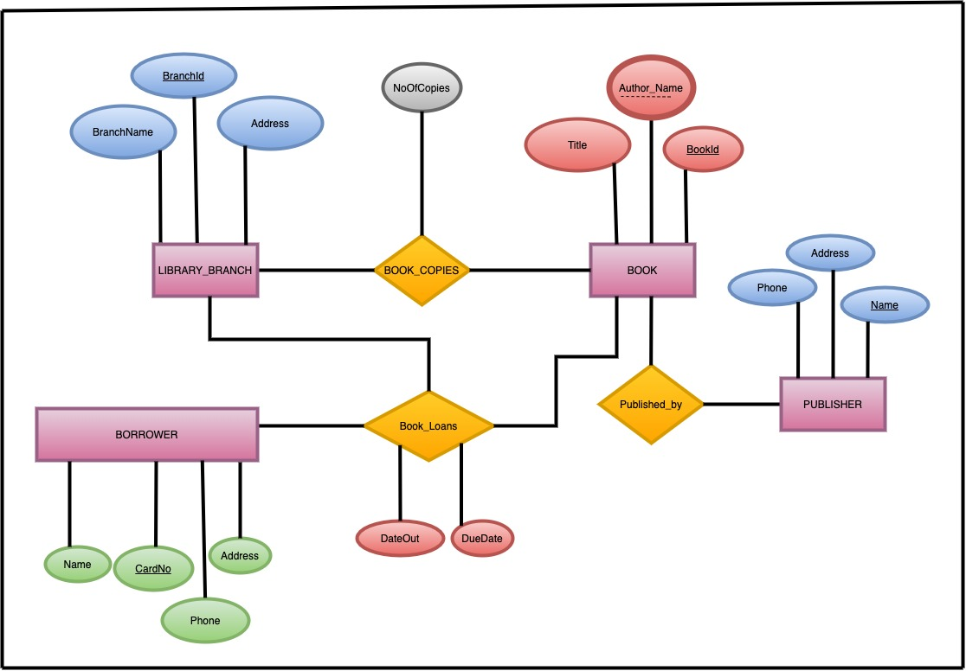

**9.5. Map the BANK ER schema of Exercise 3.23 (shown in Figure 3.21 below) into a relational schema. Specify all primary keys and foreign keys. Follow the similar example as 9.4 stated above.**

**5. Refer to the Sequence Diagram shown below. Modify the diagram as follows:**

* **Remove the 2nd Little Pig and Stick House**
* **Remove the Pot of Water.**
* **The 1st Little Pig should run to the Brick House once his house is blown (Note: the brick house needs to have been built already).**
* **The 3rd Little Pig accidentally shoots and misses when the 1st Little Pig enters.**
* **The 1st and 3rd Little Pig bind/tie up Wolf after Wolf climbs down chimney.**

